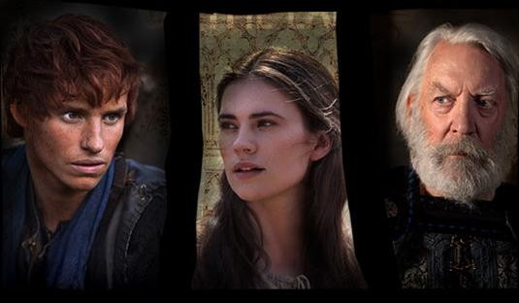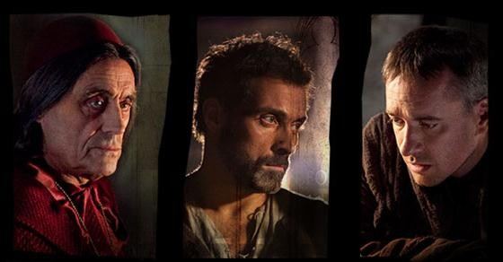The12
by Jim Rohn and Chris Widener

Pillars
Of Success

Twelve Pillars, by Jim Rohn and Chris Widener, is a short, easy to read story about a man named Michael Jones, who feels that his life is at a dead end. He meets an older gentleman, named Charlie, who shares with Michael twelve "pillars" that have helped the owner of the house Charlie maintains, Mr. Davis, achieve great success.

This pillar highlights that you can achieve only to the level where you are. Key points on this pillar are success comes when you develop yourself beyond where you currently are; read books, attend seminars/speaker engagements, study the best people; and implement and integrate what you've learned. These points remind me of the definition of insanity, doing the same thing over and over again and expecting different results. To get different results, you've got to change what you're doing. "The only way things are going to change for you
is when you change."
The Pillars
#

Personal Development

This pillar is "three dimensional health." The three dimensions are the body (physical), soul (our intellect, emotions, and will), and spirit (part of us that transcends this world). The Spirit is your core, the soul is the next layer, and the body is the outside layer. You need to work on all three, don't just work on one to the detriment of the others.
The relationship between the three dimensions highlights the need to be transparent, sincere, and genuine. Let people see you as you really are. "You should make sure the outside of you is a good reflection of the inside of you."
The Pillars
#

Total Well-being

Relationships represent the "most beautiful highs" and the "most tormented lows" of life. Relationships are the backbone of our existence. This pillar explains that relationships are like a garden, you have to cultivate them.
Once you get them up and running, the maintenance to keep them growing is much easier. "Time, effort, and imagination must be summoned constantly to keep any relationship flourishing and growing." People say that money that makes the world go around, but I believe relationships are what make the world go around because things get done through people.
The Pillars
#

The Gift of Relationships

Pillar 4 is "Achieve Your Goals." I've heard and read many times that you should write your goals down. Writing them bring them into reality. A side benefit of achieving your goals is that you become a better person. "The major reason for setting a goal is for what it makes of you to accomplish it." Something I learned from someone elsewhere is that plans will change, but your goals will stay the same. A good approach for checking your progress is "Plan, Do, Check, Adjust."
The Pillars
#

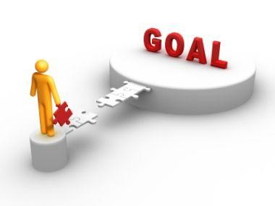

Achieve Your Goals

There are two types of pain, the pain of discipline, which weighs only ounces, and the pain of regret, which weighs tons. Don't procrastinate, the end of your life will come sooner than you expect; don't wait until it's too late. Remember that when you spend a day, you have one less day to spend, so spend each day wisely. "Every day has many opportunities, but only one best opportunity." The best opportunities are those that align with your overall goals.
Know the difference between the urgent and the important.
The Pillars
#

The Proper
Use of Time

"Don't join an easy crowd; you won't grow. Go where the expectations and the demands to perform are high."
People have an amazing power to influence your destiny. Every relationship you have is an association, be it positive, neutral, or negative. Categorize every person you meet. Is he or she someone you should disassociate with, have limited association with, or should you expand your association? Surround yourself with winners, successful people who exhibit and live consistent to values and skills you want to acquire and develop. You become like those you hang out with, so be picky.
The Pillars
#

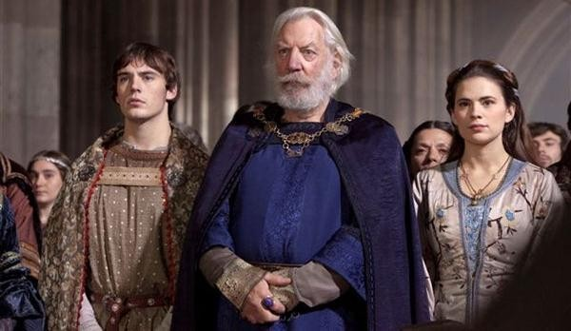
Surround Yourself With the Best People

Most of your life is lived after formal education. "Formal education will make you a living. Self education will make you a fortune." Self education is about what you teach yourself and what you learn along the way so you are constantly improving and growing. Learning is the beginning of wealth, health, and spirituality. Read books, observe successful people, reflect on your own experiences; learn what went right and what went wrong. Help others by sharing what you've learned. "All of
The Pillars
#

Be a Life-Long
Learner

Sales means influence and influence is the key to a successful life; learn the art and skill of influence. "One key to having influence with others is to have others perceive you as a person of talent and virtues." Your talent and virtues represent your character and skill. Be a person of strong character and increasing skill and you will always be growing your influence.
The Pillars
#

Life is Sales

Money doesn't solve the problems of life; you can lose it, be sued for it, or it can be stolen. What's important is what you become because, "What you become directly influences what you get." Become a million dollar person. Remember, even if you lose money, you have the skills to earn it again.
The Pillars
#

Income Seldom Exceeds Personal Development

“Communication is two or more people working together to find the common ground understanding. And when they find that common ground, they are positioned to have tremendous power together.” Communication is hard, yet important in all relationships. It's about what you say, how you say it, when you say it, and the receptiveness of who you say it to. Make sure you really listen. The character behind listening is caring enough and valuing the other person enough to want to listen. People don't care how much you know until they know how much you care.
The Pillars
#

All Communication Brings the Common Ground of Understanding

Anyone can be a great leader, all is takes is mastering the art of influence. Leaders make a difference through servant
hood. "To lead others is to help them change their thoughts, beliefs and actions for the better." Be interested in people, not just in what you can get from them. Help people with more than just their jobs, help them with their lives. Great leaders are real, they know where they are. Great leaders have an optimistic vision, they know how to get to a better destination and work towards that vision.
The Pillars
#

The World Can Always Use One More Great Leader

Life is short. You can't choose how long you will live, but you can choose how well you will live. "Live a life that will help others spiritually, intellectually, physically, financially and relationally. Live a life that serves as an example of what an exceptional life can look like." The path we walk has been prepared for us by others who have gone before us. So live your life in such a way that it will serve those who come after you. Blaze a trail that will allow others to move forward in their lives faster than if they had to blaze the trail themselves.
The Pillars
#

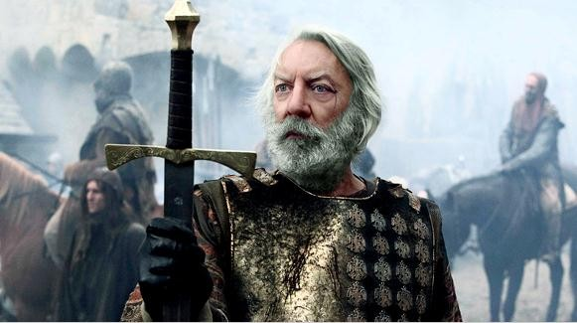

Leave a Legacy

The12 Pillars Of Success

- Personal Development
- Total Well-being
- The Gift of Relationships
- Achieve Your Goals
- The Proper Use of Time
- Surround Yourself With the Best People
- Be a Life-Long Learner
- Life is Sales
- Income Seldom Exceeds Personal Development
- All Communication Brings the Common Ground of Understanding
- The World Can Always Use One More Great Leader
- Leave a Legacy

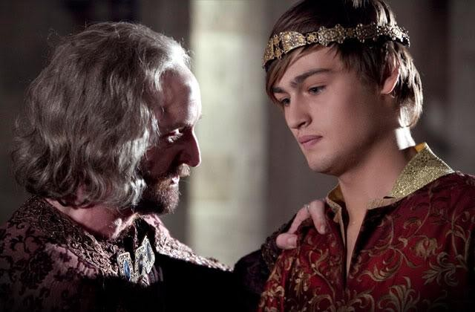

As you can see, the twelve pillars are interdependent; you can't just focus on one and neglect the others. The bottom line is that you have a choice about your life, "Make a Living or Design a Life." I hope you find value in these pillars and will be inspired to pick up Twelve Pillars and apply the pillars to your life and business.

Credit : The Pillars of The Earth movie

Thank You Very Much Sompong Yusoontorn

